POLITICAL JUGGERNAUTS  
A Quantative Analysis Of Canditates In The 2019   
Lok Sabha Election  
  
GOVERNMENT ARTS COLLEGE  
(AUTOMOUS)  
KARUR-5  
  
FACULTY MENTOR  
MISS K.KALPANA M.Sc,B.ED

TEAM MEMBERs

* S.Thamaraimalarelvi - Team Leader
* M.Varunmoorthy - Team Member
* N.Vinothkumar - Team Member
* P.Vishnupriya - Team Member

INTRODUCTION

1. An election may be defined as an act of chooing or selecting canditates into different in government.
2. The canditate are represent the people of a country in parliament or other position of government.

PURPOSE

1. Accountablility of government
2. Legitimacy of government
3. Communication link
4. Political education

EMPATHY MAP

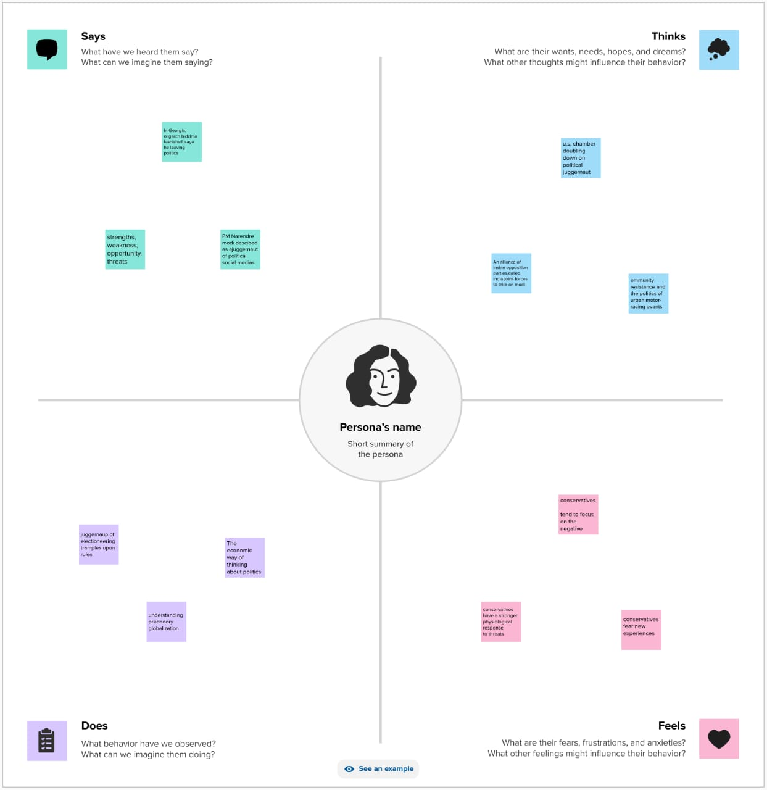

BRAINSTORM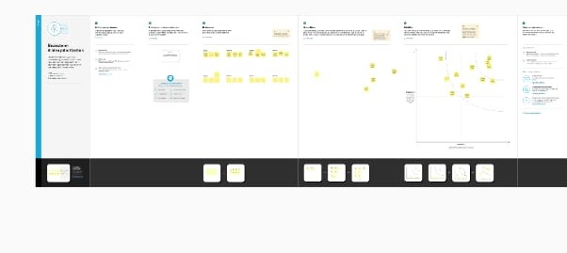

ABOUT DATASET

1. State: Dimension in lg data represent states names
2. Constituency: It shows dimension of constituency o states
3. Name: participate name from their party
4. Symbol: part of symbol
5. Part: name of party
6. Gender: gender of participant
7. Criminal cases: cases on party participant
8. Category: BC SC OBC
9. Winner: winners in data
10. Age: age of candite
11. General votes: shows total general vote
12. Potal votes: potal vote from country
13. Total electors: total count of electors in a country

DASBOARD

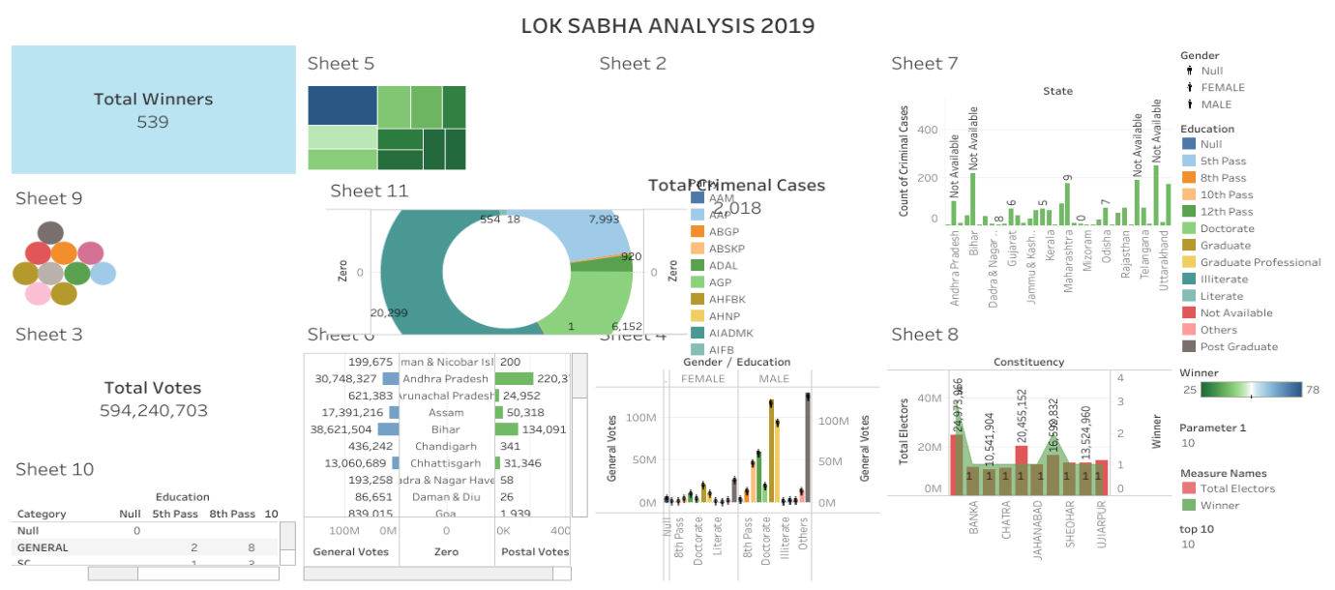

STORY

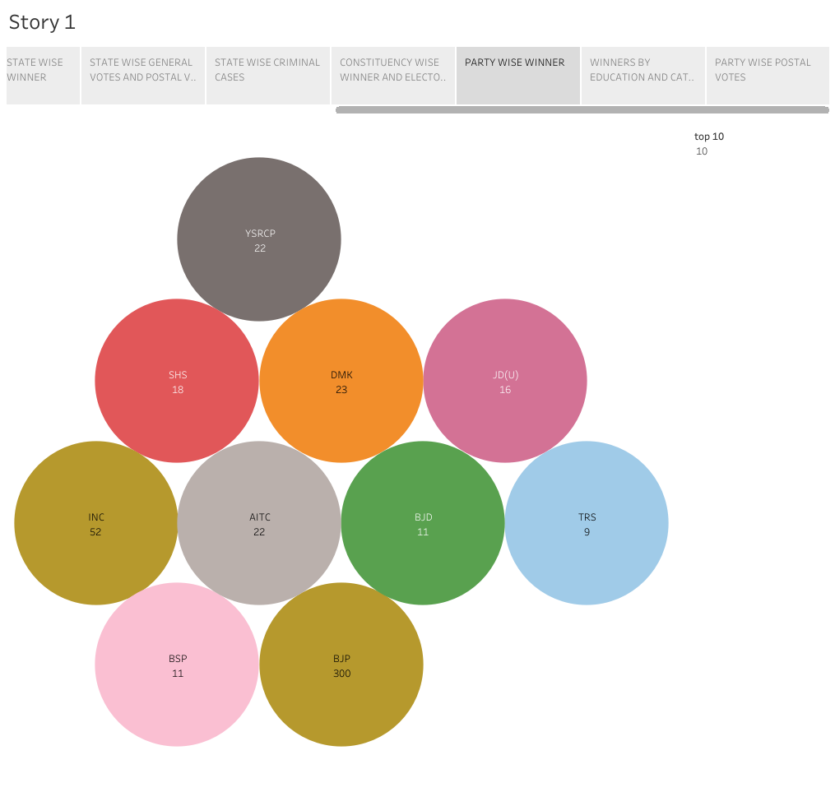

ADVANTAGES

1. Election are used to change a government smoothly
2. Election help to integrate the different societies
3. Election help to socialize the people

DISADVANTAGES

1. Elections are too expensive to conduct
2. Minority groups are usually not favoured during election
3. Election breeds nepotism divisionism and ethnocentrism

CONCLUSION

A election is formal group decision making . To elect means “ to select or make a decision ” . “ my vote is my future power of one vote”.

FUTURE HOPE

An election has change the future. To our younger generation as we say that voting is your right and your duty